A000-Eur-Spain-Atapuerca-Hammerstone-Early Lower Paleolithic-1 mya

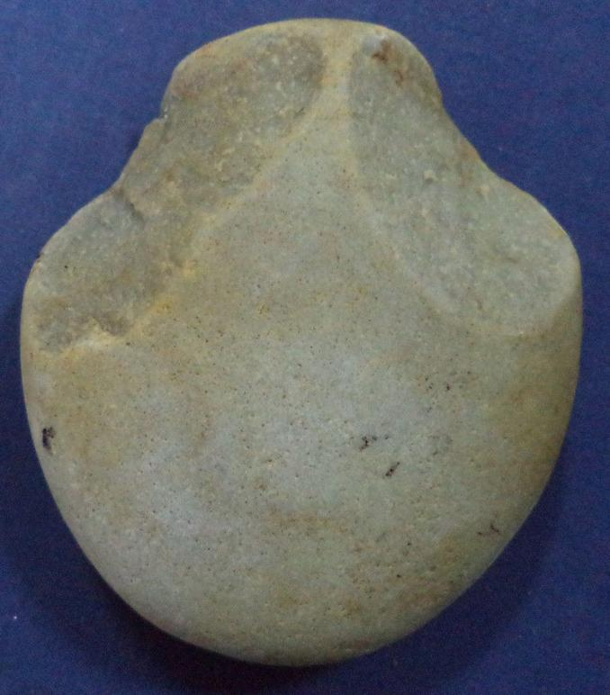 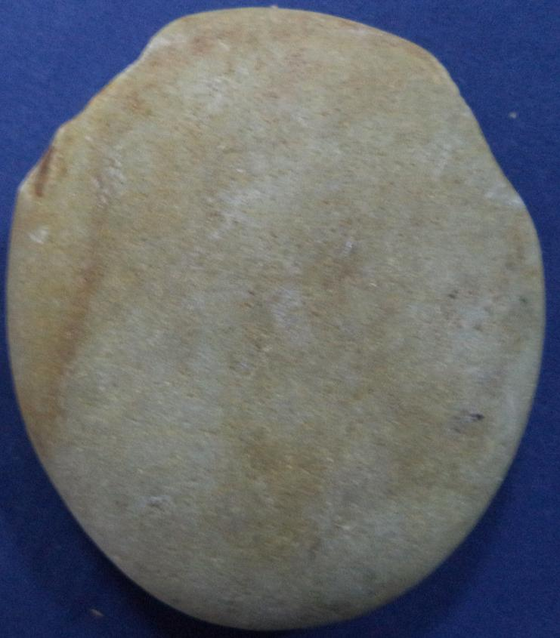

Figs. 1`-2. Eur-Spain-Hammerstone-Early Lower Paleolithic-1 mya

Case no.: 1

Accession Number:

Formal Label: Eur-Spainl-Hammerstone-Early Lower Paleolithic-1 mya

**Display Description:**

The prehistory of the Iberian Peninsula begins with the arrival of the first hominins 1.2 million years ago.  Many prehistoric remains are in the Atapuerca region’s limestone caves such the Gran Dolina cave, where six hominin skeletons, dated 1.2 million-780,000 BP, were found in 1994. These skeletons are possibly of *Homo erectus*, *Homo heidelbergensis*, or a new species called *Homo antecessor*. Evidence of tool use to butcher animals and other hominins, which may be the first evidence of cannibalism by a hominin species, has been found in the Gran Dolina cave. This very crude cobble tool was found in the area and was probably flaked in two places to create a hand-held position. Its use was probably as a hammerstone.

**LC Classification: GN7899. T6**

Date or Time Horizon: 100,000 BP

Geographical Area: western Iberian peninsula

**Map:**

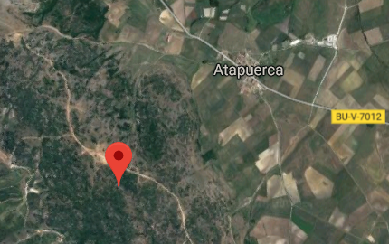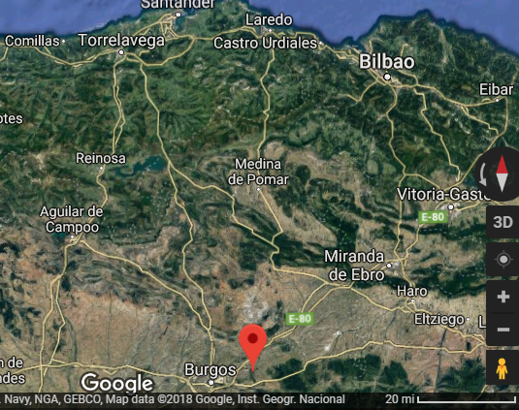

**Figs. 3-4. Google maps of the location of the Gran Dolina cave in the Atapuerca region of northern Spain.**

**GPS coordinates: 42°22'00.0"N 3°31'20.0"W**

Cultural Affiliation: Iberian Lower Paleolithic

Medium: silicified sandstone

Dimensions: 9,7 cms high; 8,4 cms long

Weight: 324 grams

Condition: original

Provenance:

**Discussion:**

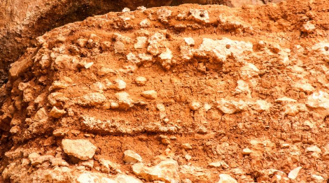

Fig. 5. Atapuerca site strata showing some water worn cobbles that resemble the current specimen after [https://www.werelderfgoedfotos.nl/images/galleries/213/full/0611.Archaeological%20Site%20of%20Atapuerca%20-%20Photo%20by%20Albertine%20Slotboom.jpg](https://www.werelderfgoedfotos.nl/images/galleries/213/full/0611.Archaeological Site of Atapuerca - Photo by Albertine Slotboom.jpg)

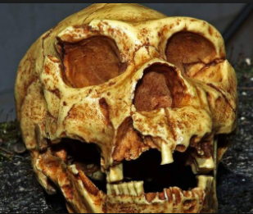 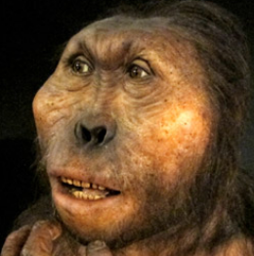

Fig 6.One of the skulls excavted at Atapuerca. After <https://www.turismocastillayleon.com/en/art-culture-heritage/archaeological-sites/archeological-sites-atapuerca.files/39906-37146_SC_1.jpg?clipX=0&clipY=27&clipWidth=1440&clipHeight=520>

Fig. 7. Reconstruction of a hominin from an excavted askull, after http://www.terranostrum.es/images/content/full/museo-evolucion-9.jpg

“This is one of the world’s most important archaeological sites, questioning previous suppositions regarding the very nature of the evolution of our species, and providing a new perspective to our ’family tree’. Considerations that make Atapuerca fully deserving of its World Heritage status, awarded in 1997.

The tour of the site takes visitors along the ’Railway Trench’ where various fossil sediments were discovered. Access is permitted at several points: the "Sima del Elefante", " Complejo Galería" and the "Gran Dolina". Here fossils of up to five different species were discovered that succeeded one another over time although the most important are those corresponding to the "Homo Antecessor" and the "Homo heidelbergensis". Thanks to these discoveries, evidence has been found for a long and crucial period in the sequence of human evolution in Europe.” After https://www.turismocastillayleon.com/en/art-culture-heritage/archaeological-sites/archeological-sites-atapuerca#locale=en_UK!nearLat=42.349841999999995!nearLon=-3.5193970000000063!nearDistance=40!minLat=42.35023052452706!minLon=-3.51837105505183!maxLat=42.34910260740559!maxLon=-3.521088132783916!zoom=19

**References:**

https://www.turismocastillayleon.com/turismocyl-client/cm/gallery/visitas_virtuales/Atapuerca/Atapuerca.html